**Find Your Dream Car**



A

Human Computer Interface Course Project Report in

partial fulfilment of the degree

**Bachelor of Technology**  **Computer Science & Engineering**

in

**By**

KOUSHAL PALA 2303A51249

NISHANTH DADI 2303A51235

Under the guidance of

**Dr.DEEPAN**

Designation

Assistant Professor

**Submitted to**

**School of Computer Science and Artificial Intelligence**





**DEPARTMENT OF COMPUTER SCIENCE & ENGINEERING**

**CERTIFICATE**

This is to certify that the **Human Computer Interface - Course Project** Report entitled **“**  **Find Your Dream Car _____ ”** is a record of bonafide work carried out by the student **Koushal pala, Dadi Nishanth** bearing Roll No(s) **2303A51249,2303A51235**during the academic year 2024-25 in partial fulfillment of the award of the degree of ***Bachelor of Technology*** in **Computer Science & Engineering** by the **SR University, Warangal.**



### ACKNOWLEDGEMENT

We owe an enormous debt of gratitude to our project guide Mr.DEEPAN, Assistant Professor .Head of the CSE Department Dr. M. Sheshikala, Associate Professor for guiding us from the beginning through the end of the Project with their intellectual advises and insightful suggestions. We truly value their consistent feedback on our progress, which was always constructive and encouraging and ultimately drove us to the right direction.

We wish to take this opportunity to express our sincere gratitude and deep sense of respect to our beloved Vice Chancellor, Prof. Deepak Garg, for his continuous support and guidance to complete this project in the institute.

Finally, we express our thanks to all the teaching and non-teaching staff of the department for their suggestions and timely support.

**Table of Contents**

**Page no.**

#### Abstract…………………………………………………………………………………………………… 05 1.Objective of the Project…………………………………………………………………………. 05 2. Definitions of the Elements Used in the Project……………………………………. 06 3. Design………………………………………………………………………………………………….. 06

**3.1. Screens……………………………………………………………………………………. 06**

**4. Implementation…………………………………………………………………………………… 09**

4.1. Code 9

5. Result Screens 18

6. Conclusion 19

### Abstract

#### 1.Objective of the Project:-

1. The primary goal of the "Find Your Dream Car" website is to create a comprehensive and user-friendly platform that allows users to explore and purchase cars. The website aims to cater to a diverse audience by offering a wide range of both luxury and affordable cars, ensuring that every user can find a vehicle that suits their preferences and budget.
2. **Features:**
3. **Detailed Listings:** Each car listing includes high-quality images, detailed descriptions, specifications, and pricing information. Users can view multiple images and detailed views of each car.

**Virtual Tour:** Integration of 360-degree virtual tours allows users to explore the car interiors and exteriors virtually, providing an immersive experience.

1. **Comparison Tool:** Users can compare multiple cars side by side, evaluating their features, specifications, and prices to make informed decisions.
2. **Customer Reviews:** Incorporating customer reviews and ratings provides real-world insights into the performance and satisfaction of each car model.
3. **Financing Options:** Information on financing options and calculators to estimate monthly payments, making it easier for users to understand their purchasing power.
4. **User Accounts:** Users can create accounts to save their favorite cars, view their browsing history, and receive personalized recommendations.
5. **Contact and Support:** Easy access to contact forms, live chat support, and dealership locations to assist users with their inquiries and purchases.

#### 2.Definitions of the Elements Used in the Project:-

**HTML (Hypertext Markup Language):** The structural foundation that organizes and delineates content on the webpage, ensuring optimal hierarchy and accessibility. **CSS (Cascading Style Sheets):** The styling language applied to create a visually stunning layout, incorporating contemporary design principles and branding elements.

**JavaScript:** A scripting language that can be used to implement dynamic features such as interactive product filtering, cart updates, and wishlist functionality, enhancing user experience.

**Responsive Design:** Techniques used to ensure that the site adapts fluidly to different screen sizes, allowing for an optimized experience on desktops, tablets, and mobile devices.

#### 2. Design

The design philosophy behind the Find Your Dream Car website centers on modern aesthetics combined with practical usability. The layout is thoughtfully structured to facilitate a natural flow of information, guiding users toward their desired actions. The following screens exemplify this engaging design:

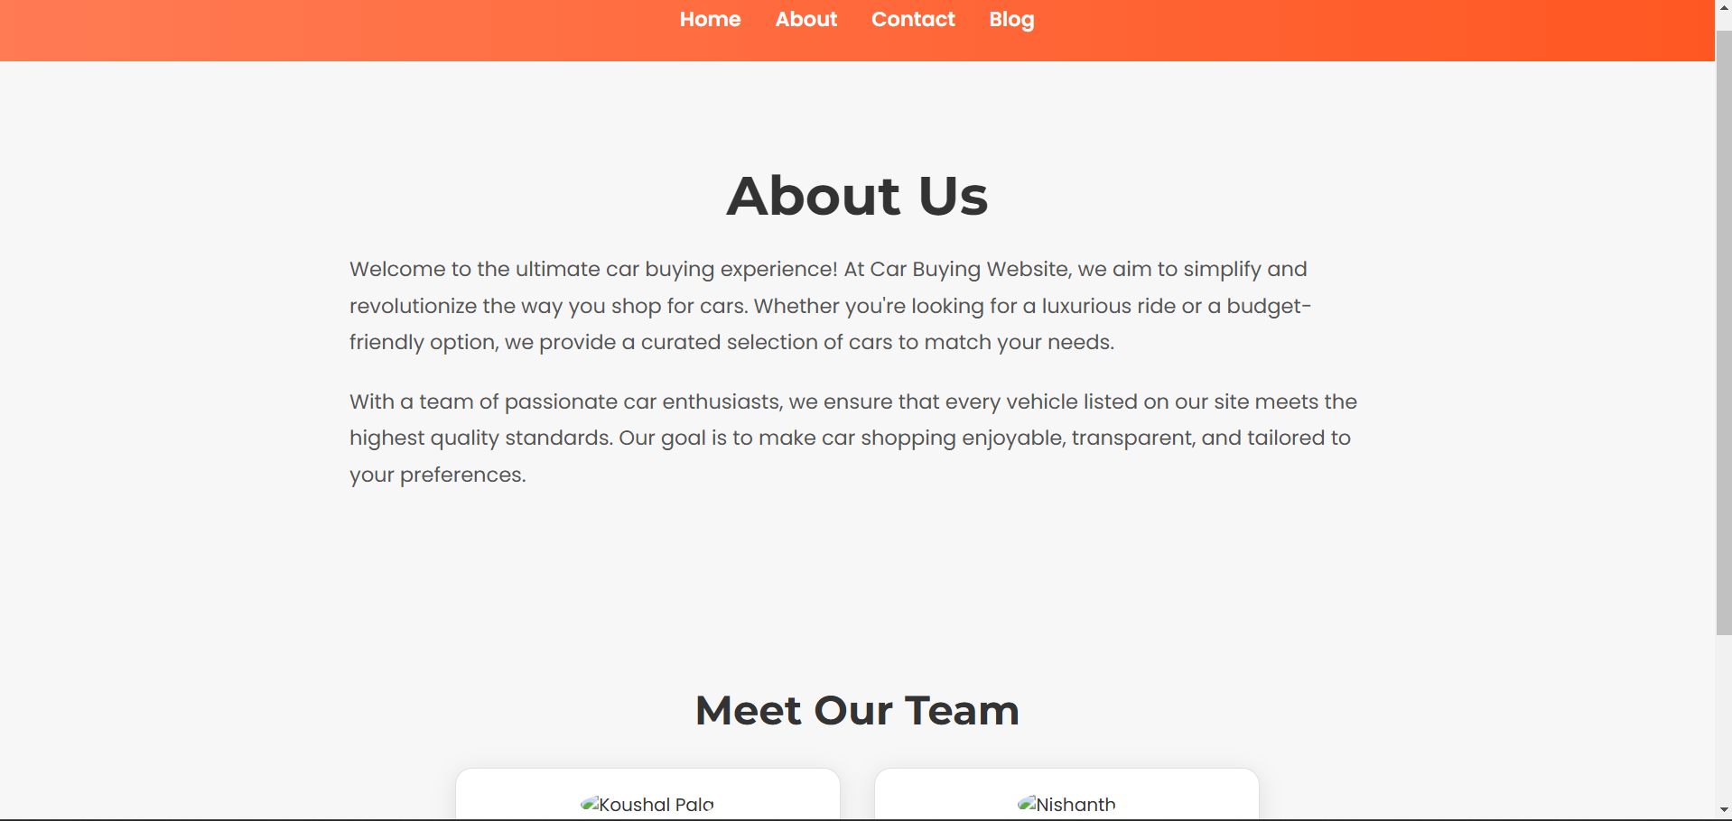

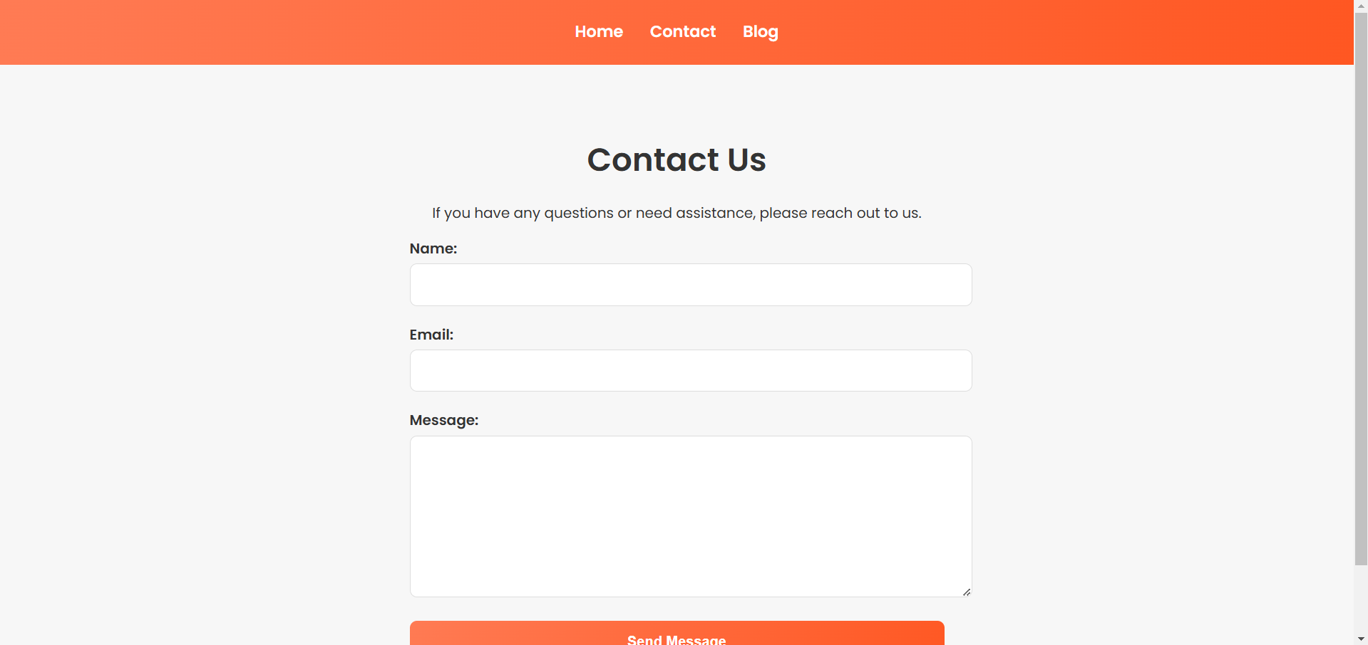

##### 3.1. Screens

**Home Screen:** The home page serves as an inviting entry point, featuring a prominent hero section that showcases seasonal promotions, highlighted products, and visually appealing banners that lead to various categories.

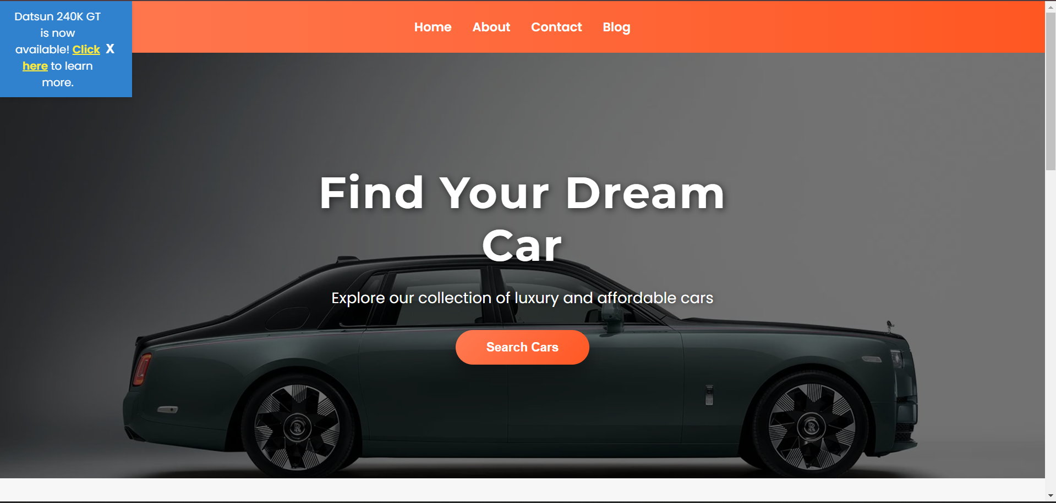

**Product Listing:** A visually rich display of products featuring high-resolution images, engaging product descriptions, and dynamic pricing. Users can filter products by category, price range, or popularity, making their shopping more efficient.

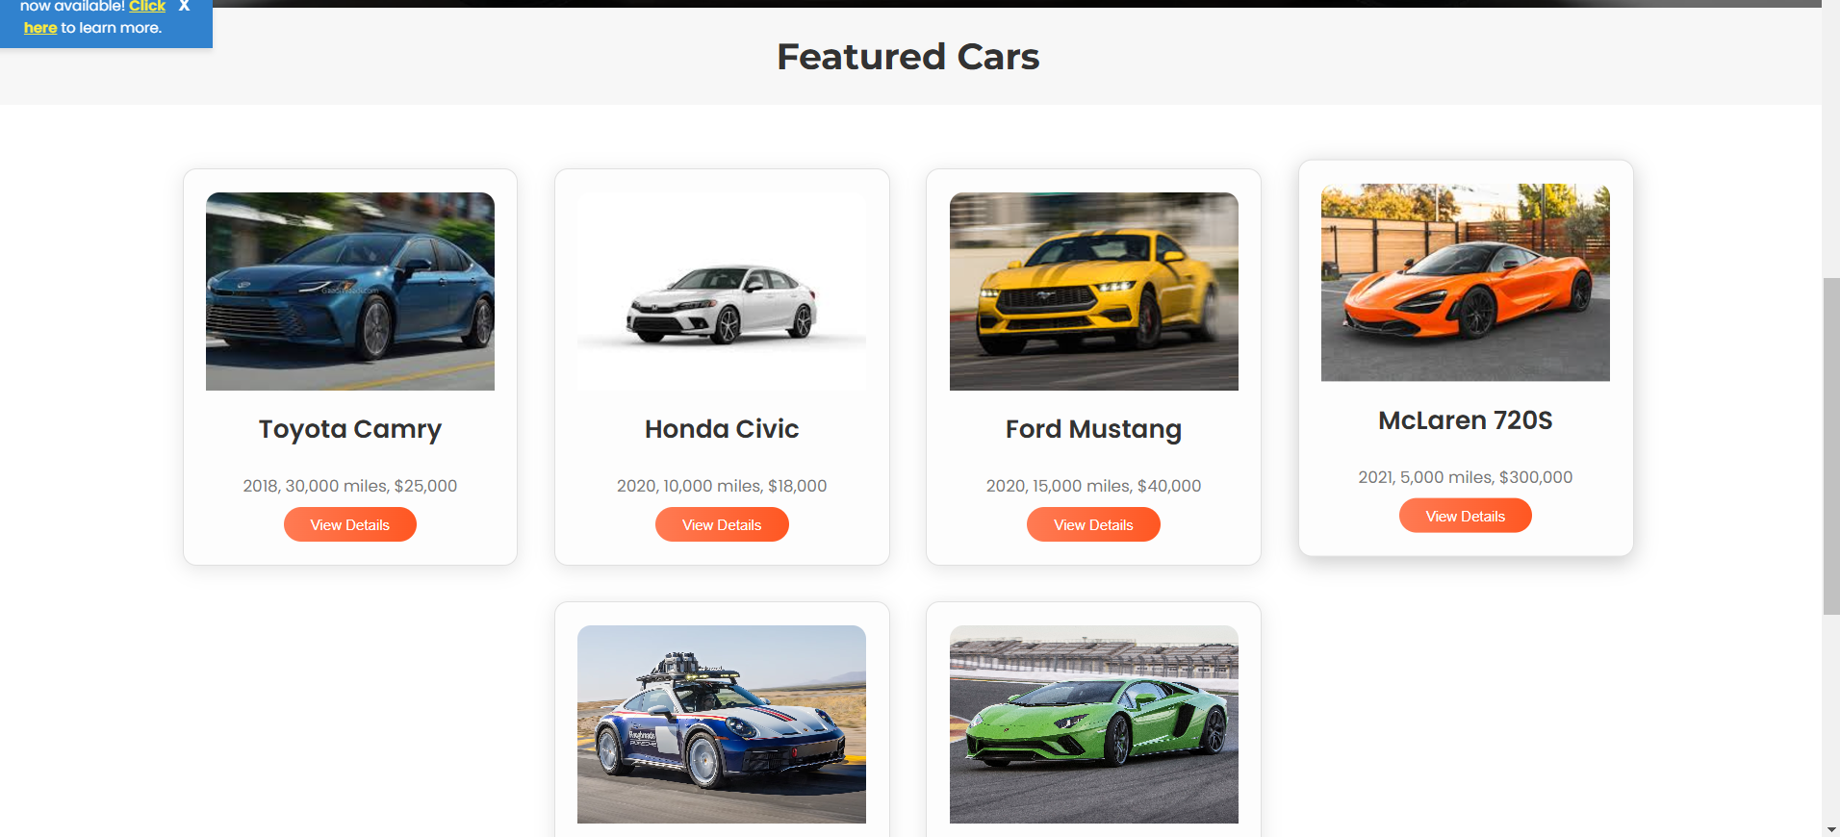

**Product Details:** This screen provides an immersive experience with extensive product descriptions, multiple images, customer reviews, and related product suggestions. The layout facilitates easy navigation to add items and provides options for sharing products on social media.

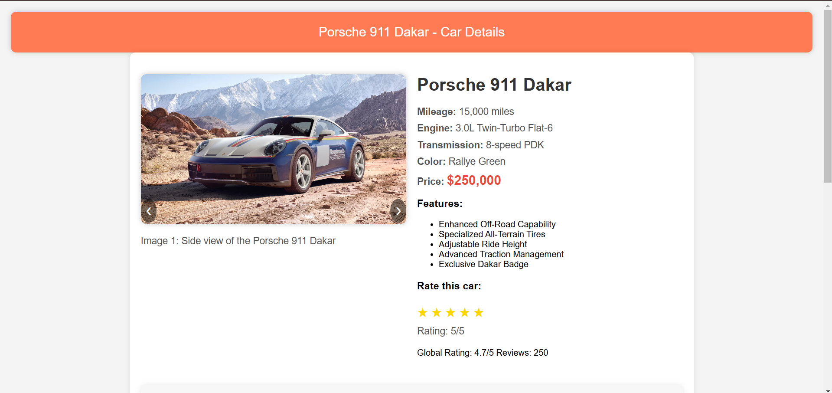

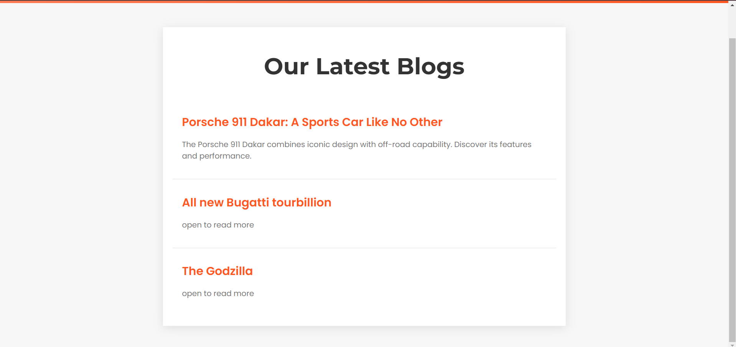

#### 4. Implementation:-

The implementation phase combines robust coding practices with the latest web technologies. Utilizing HTML and CSS for the foundational structure and aesthetics ensures a responsive and reliable experience for users. The code showcases wellorganized sections that cover all essential components of the Woodex site, from headers and navigational elements to detailed product cards and wishlist functionalities.

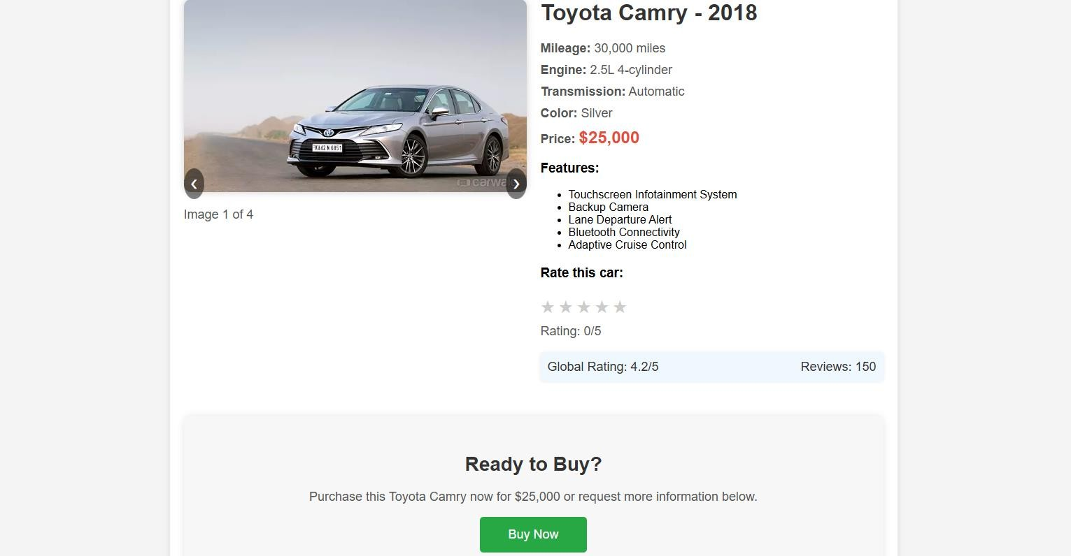

## 4.1. Code:-

The underlying HTML and CSS code establish a solid framework for the Find Your Dream Car site. Code snippets demonstrate how product cards are rendered, how the wishlist is integrated, and how buttons are designed for optimal interactivity. Leveraging responsive design principles guarantees that the site provides a consistent and highquality experience across all devices, from desktops to smartphones.

# <!DOCTYPE html>

# <html lang="en">

# <head>

# <meta charset="UTF-8">

# <meta name="viewport" content="width=device-width, initial-scale=1.0">

# <title>Car Buying Website</title>

# <!-- Import Google Fonts for better typography -->

# <link href="https://fonts.googleapis.com/css2?family=Poppins:wght@400;600&family=Montserrat:wght@300;700&display=swap" rel="stylesheet">

# <link rel="stylesheet" href="path/to/dark-theme.css">

# <style>

# body {

# font-family: 'Poppins', sans-serif;

# margin: 0;

# padding: 0;

# background-color: #f7f7f7;

# color: #333;

# }

# /* Notification Banner */

# .notification-banner {

# background-color: #3182ce;

# color: white;

# padding: 10px 20px;

# font-size: 16px;

# text-align: center;

# position: fixed;

# top: 100;

# left: 0;

# width: 10%;

# z-index: 9999;

# display: flex;

# justify-content: space-between;

# align-items: center;

# box-shadow: 0 4px 6px rgba(0, 0, 0, 0.1);

# }

# .notification-link {

# color: #ffeb3b;

# font-weight: bold;

# text-decoration: underline;

# }

# .notification-link:hover {

# color: #ffd600;

# }

# .close-btn {

# background: none;

# color: white;

# border: none;

# font-size: 18px;

# cursor: pointer;

# font-weight: bold;

# }

# .close-btn:hover {

# color: #e53e3e;

# }

# header {

# background: linear-gradient(90deg, #ff7b54, #ff5722);

# color: #fff;

# padding: 1.5em;

# text-align: center;

# }

# nav ul {

# list-style: none;

# margin: 0;

# padding: 0;

# display: flex;

# justify-content: center;

# gap: 30px;

# }

# nav a {

# color: #fff;

# text-decoration: none;

# font-weight: 600;

# font-size: 18px;

# transition: color 0.3s ease;

# }

# nav a:hover {

# color: #ffd9b3;

# }

# /* Hero Section */

# .hero-container {

# height: 85vh;

# display: flex;

# justify-content: center;

# align-items: center;

# position: relative;

# background-image: url('hero-image.jpg');

# background-size: cover;

# background-position: center;

# position: relative;

# }

# .hero-overlay {

# position: absolute;

# top: 0;

# left: 0;

# width: 100%;

# height: 100%;

# background: rgba(0, 0, 0, 0.55);

# z-index: 1;

# }

# .hero-content {

# text-align: center;

# color: #fff;

# position: relative;

# z-index: 2;

# padding: 60px;

# max-width: 600px;

# }

# .hero-content h1 {

# font-size: 64px;

# font-weight: 700;

# margin: 0 0 20px 0;

# font-family: 'Montserrat', sans-serif;

# text-shadow: 2px 2px 10px rgba(0, 0, 0, 0.6);

# letter-spacing: 2px;

# line-height: 1.2;

# }

# .hero-content p {

# font-size: 22px;

# margin-bottom: 30px;

# text-shadow: 1px 1px 8px rgba(0, 0, 0, 0.5);

# line-height: 1.5;

# }

# .hero-content button {

# background: linear-gradient(135deg, #ff7b54, #ff5722);

# color: #fff;

# border: none;

# padding: 15px 45px;

# font-size: 18px;

# font-weight: 600;

# cursor: pointer;

# border-radius: 40px;

# box-shadow: 0px 12px 20px rgba(0, 0, 0, 0.3);

# transition: all 0.4s ease;

# }

# .hero-content button:hover {

# background: linear-gradient(135deg, #ff5722, #ff7b54);

# transform: translateY(-5px);

# box-shadow: 0px 15px 25px rgba(0, 0, 0, 0.4);

# }

# /* Car Listing Section */

# .car-listings-container {

# display: flex;

# flex-wrap: wrap;

# justify-content: center;

# padding: 50px 0;

# background-color: #fff;

# }

# .car-card {

# margin: 20px;

# padding: 25px;

# border-radius: 15px;

# background-color: #fdfdfd;

# border: 1px solid #e0e0e0;

# box-shadow: 0 4px 20px rgba(0, 0, 0, 0.1);

# transition: transform 0.3s ease, box-shadow 0.3s ease;

# width: 320px;

# text-align: center;

# }

# .car-card:hover {

# transform: translateY(-10px);

# box-shadow: 0 6px 25px rgba(0, 0, 0, 0.2);

# }

# .car-card img {

# width: 100%;

# height: 220px;

# object-fit: cover;

# border-radius: 15px 15px 0 0;

# }

# .car-card h3 {

# font-size: 28px;

# margin-top: 15px;

# font-weight: 600;

# }

# .car-card p {

# font-size: 18px;

# color: #777;

# margin: 10px 0;

# }

# .car-card button {

# background: linear-gradient(90deg, #ff7b54, #ff5722);

# color: #fff;

# border: none;

# padding: 10px 30px;

# font-size: 16px;

# cursor: pointer;

# border-radius: 40px;

# transition: all 0.3s ease;

# }

# .car-card button:hover {

# background: linear-gradient(90deg, #ff5722, #ff7b54);

# }

# /* Hiring Section */

# .hiring-section {

# background-color: #ffece5;

# padding: 50px 0;

# text-align: center;

# }

# .hiring-section h2 {

# font-family: 'Montserrat', sans-serif;

# font-size: 36px;

# margin-bottom: 20px;

# }

# .hiring-section p {

# font-size: 20px;

# color: #555;

# margin-bottom: 30px;

# }

# .hiring-section button {

# background-color: #ff5722;

# color: white;

# border: none;

# padding: 15px 40px;

# font-size: 18px;

# font-weight: 600;

# cursor: pointer;

# border-radius: 40px;

# transition: background-color 0.3s ease;

# }

# .hiring-section button:hover {

# background-color: #ff7b54;

# }

# /* Global Style Adjustments */

# h2 {

# text-align: center;

# font-size: 40px;

# margin: 30px 0;

# font-family: 'Montserrat', sans-serif;

# font-weight: 700;

# }

# </style>

# </head>

# <body>

# <!-- Notification Banner -->

# <div id="notification" class="notification-banner">

# <span id="notification-message">Datsun 240K GT is now available! <a href="#inner-1" class="notification-link">Click here</a> to learn more.</span>

# <button id="close-notification" class="close-btn">X</button>

# </div>

# <!-- Header Section -->

# <header>

# <nav>

# <ul>

# <li><a href="#home">Home</a></li>

# <li><a href="about.html">About</a></li>

# <li><a href="contact.html">Contact</a></li>

# <li><a href="blog-list.html">Blog</a></li> <!-- Added Blog button -->

# </ul>

# </nav>

# </header>

# <!-- Hero Section -->

# <section id="home">

# <div class="hero-container">

# <div class="hero-overlay"></div>

# <div class="hero-content">

# <h1>Find Your Dream Car</h1>

# <p>Explore our collection of luxury and affordable cars</p>

# <button>Search Cars</button>

# </div>

# </div>

# <!-- Car Listings Section -->

# <section id="car-listings">

# <h2>Featured Cars</h2>

# <div class="car-listings-container">

# <div class="car-card">

# <img src="car1.jpg" alt="Toyota Camry">

# <h3>Toyota Camry</h3>

# <p>2018, 30,000 miles, $25,000</p>

# <a href="car1.html">

# <button>View Details</button>

# </a>

# </div>

# <div class="car-card">

# <img src="car2.jpg" alt="Honda Civic">

# <h3>Honda Civic</h3>

# <p>2020, 10,000 miles, $18,000</p>

# <a href="car2-details.html">

# <button>View Details</button>

# </a>

# </div>

# <div class="car-card">

# <img src="car3.jpg" alt="Ford Mustang">

# <h3>Ford Mustang</h3>

# <p>2020, 15,000 miles, $40,000</p>

# <a href="car3-details.html">

# <button>View Details</button>

# </a>

# </div>

# <!-- New Car Cards -->

# <div class="car-card">

# <img src="mclaren-720s.jpg" alt="McLaren 720S">

# <h3>McLaren 720S</h3>

# <p>2021, 5,000 miles, $300,000</p>

# <a href="mclaren-720s.html">

# <button>View Details</button>

# </a>

# </div>

# <div class="car-card">

# <img src="porsche-911-dakar.jpg" alt="Porsche 911 Dakar">

# <h3>Porsche 911 Dakar</h3>

# <p>2022, 2,000 miles, $200,000</p>

# <a href="porsche-911-dakar.html">

# <button>View Details</button>

# </a>

# </div>

# <div class="car-card">

# <img src="lamborghini-aventador.jpg" alt="Lamborghini Aventador">

# <h3>Lamborghini Aventador</h3>

# <p>2019, 8,000 miles, $400,000</p>

# <a href="lamborghini-aventador.html">

# <button>View Details</button>

# </a>

# </div>

# </div>

# </section>

# <!-- We're Hiring Section -->

# <section class="hiring-section">

# <h2>We're Hiring!</h2>

# <p>Join our dynamic team and help us make car buying a better experience for everyone.</p>

# <a href="careers webpage.html">

# <button>Explore Careers</button>

# </a>

# </section>

# </body>

# </html>

# 5. Result Screens

*Confirmation Message:*

Thank you for reaching out to us. We have received your inquiry and our team will contact you within the next 24 hours with detailed information about your chosen car. We are excited to help you find your dream car and make the buying process as smooth as possible.

*Additional Information:*

In the meantime, feel free to browse our collection of luxury and affordable cars. If you have any immediate questions, you can contact us at [email@example.com] or call us at [Phone Number].

Stay tuned for more updates and let us know if there's anything else we can assist you with.

*Call to Action:*

**Back to Home:** Button to navigate back to the homepage. **Browse More Cars:** Button to explore more cars in the collection.

.

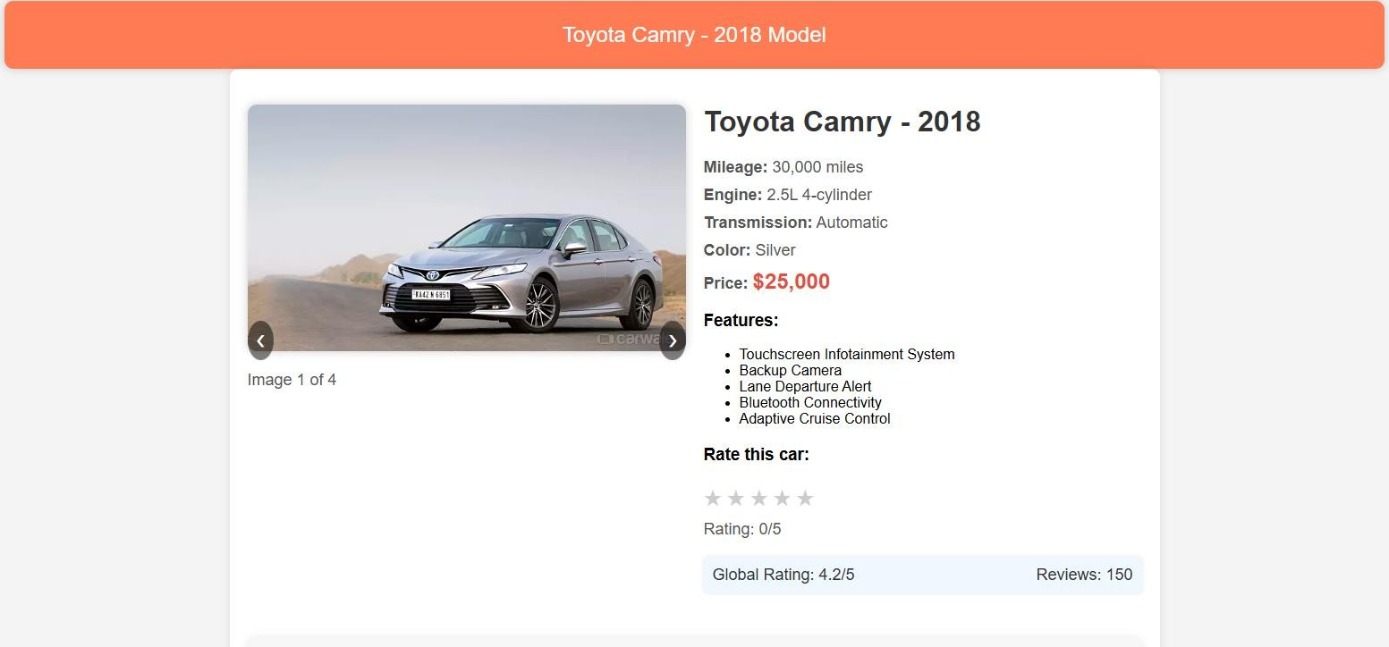

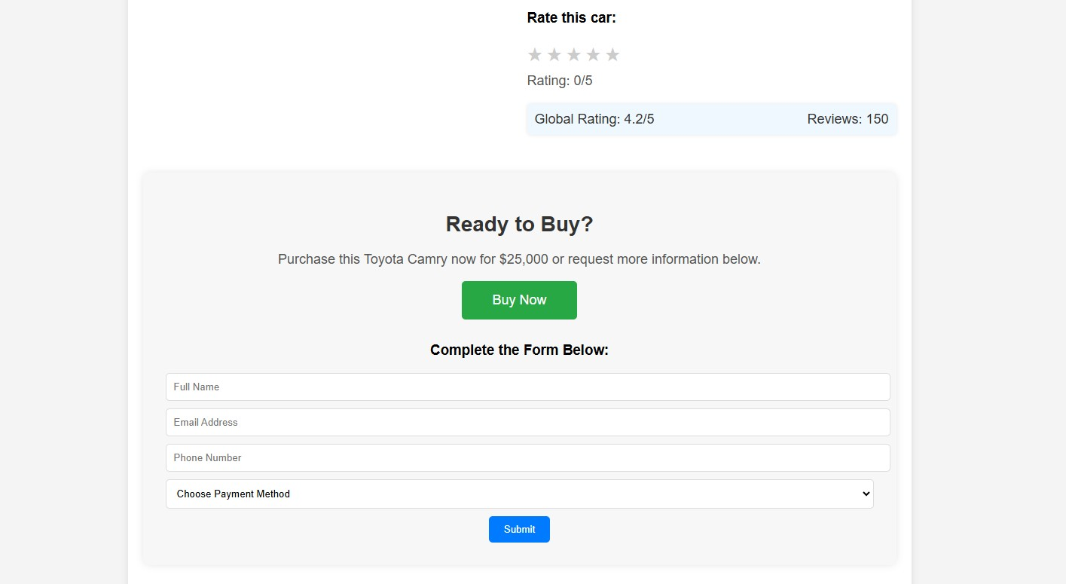

# 6.Conclusion

The "Find Your Dream Car" website is a revolutionary platform designed to make the car buying experience seamless, enjoyable, and efficient. By offering an extensive collection of both luxury and affordable cars, detailed listings, advanced search and filter options, virtual tours, and comprehensive customer reviews, we ensure that users can find the perfect vehicle to suit their needs and preferences.

Our "Ready to Buy?" section further enhances the user experience by providing a simple and effective way for potential buyers to express their interest and receive personalized assistance from our team. With a user-centric approach, we prioritize customer satisfaction by offering timely support and detailed information, ensuring that every interaction is meaningful and productive.

As we continue to innovate and improve, our commitment remains steadfast: to help users find their dream car and make the buying process as smooth and enjoyable as possible. Thank you for choosing "Find Your Dream Car" as your trusted partner in this exciting journey.

Feel free to explore our website, reach out with any questions, and let us assist you in finding the perfect car that matches your desires and budget. Together, let's drive towards a bright and fulfilling future.